Emotion

Linsear Write

Reading Ease

Sarcasm Indicator

Sentiment

4

**Sentiment**

**Emotion**

1. Don’t panic

d07frp.gif

8aex04.gif

4h2y6b.gif

4h294q.gif

1. No problem.

d07frp.gif

**8aex04.gif**

4h2y6b.gif

4h294q.gif

1. excited!

No match

1. Confused

b1uh64.gif

9vp479.gif

7v14a8.gif

2xhvsy.gif

1. congratulations

9fuuxa.gif

34ongo.gif

1. Nervous

coog04.gif

1. Aww

fe8x2m.gif

f7uwv3.gif

ci8goj.gif

**9w11n5.gif**

1. Bored

**fe8x2m.gif**

f7uwv3.gif

ci8goj.gif

9w11n5.gif

1. Sad

No match

1. That’s a good call.

54adru.gif

1. That’s insane.

**5ckguc.gif**

3o88nu.gif

1. I got this.

m3dsep.gif

**ii0bs9.gif**

eggkl6.gif

ciplx1.gif

bshlqj.gif

1. I just submitted the application.

jxz2i2.gif

iqpy5c.gif

**gfxsw8.gif**

…

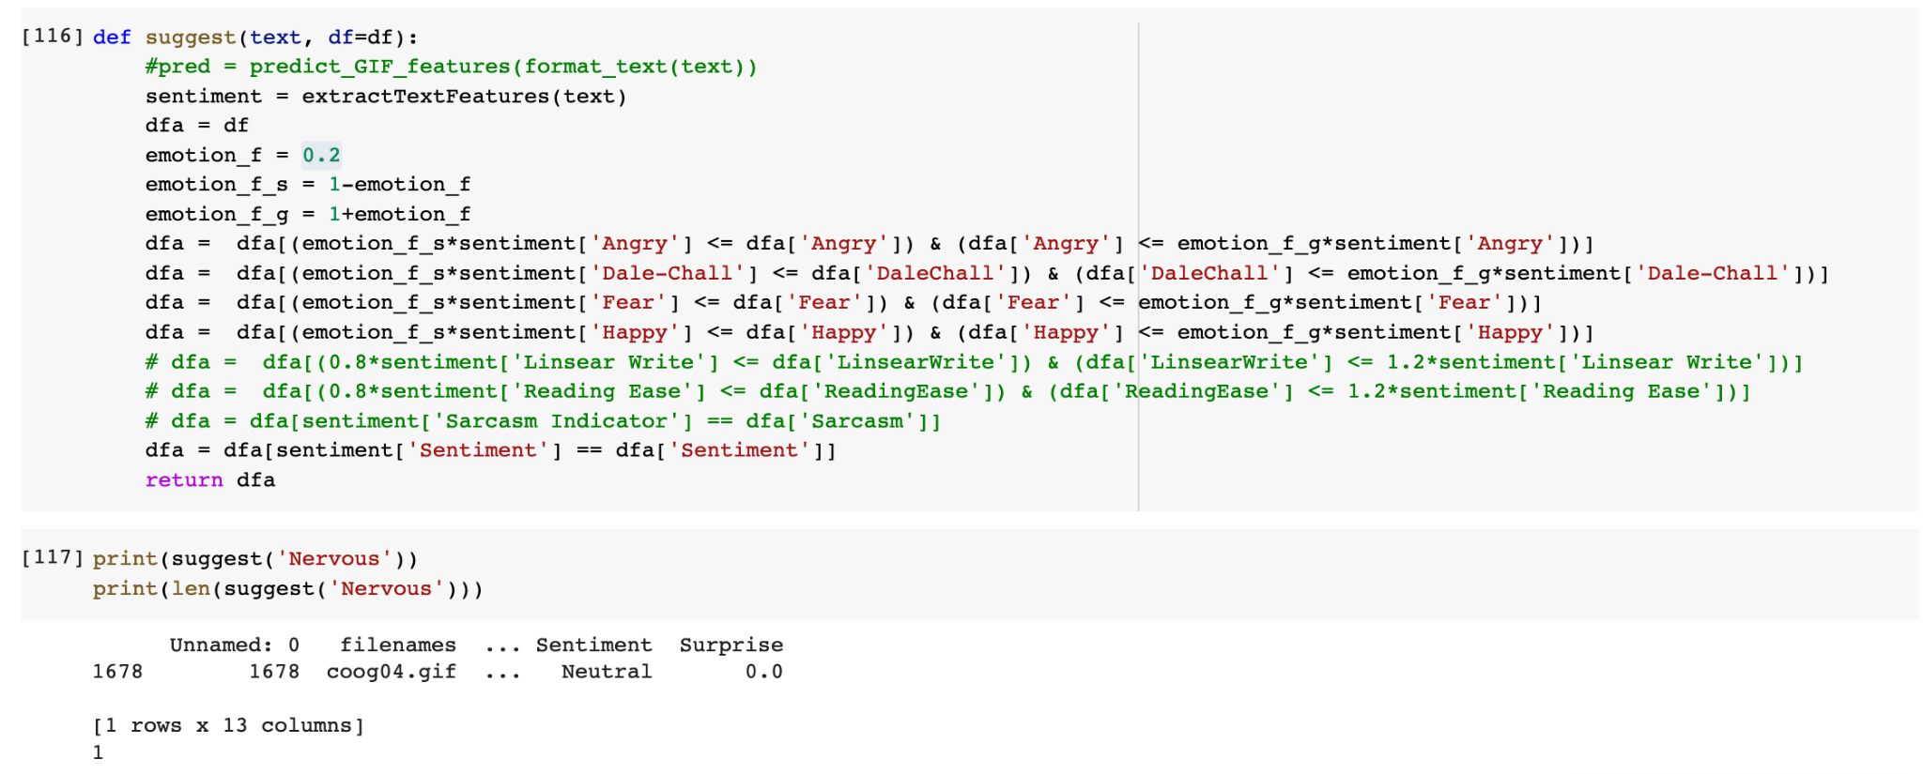

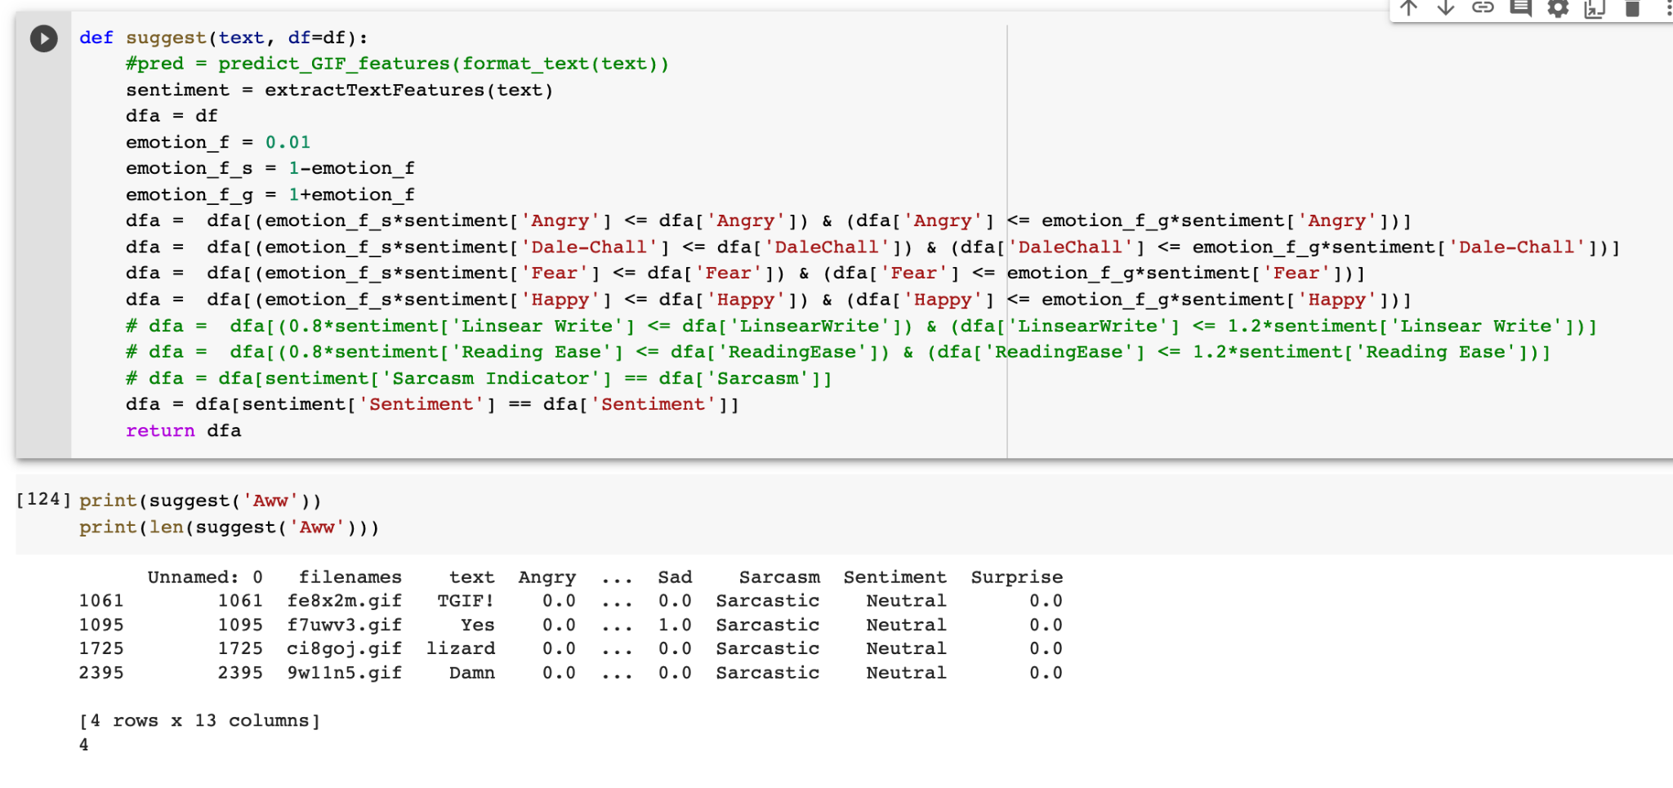

**2.**

**Emotion**

**Sentiment**

**Linsear Write**

|  |  |  |  |  |
| --- | --- | --- | --- | --- |
| Sentence | Filenames | Emotion Factor | Linsear Write  Factor | Number of match |
| Don’t panic | 1516 dandqu.gif | 0.99999 | 0.99999 | 1 |
| No problem. | 1516 dandqu.gif | 0.99999 | 0.99999 | 1 |
| excited! | None |  |  |  |
| Confused | None |  |  |  |
| congratulations | 2561 9fuuxa.gif  5358 34ongo.gif | 0.5 | 0.5 | 2 |
| Nervous | None |  |  |  |
| Aww | None |  |  |  |
| Bored | None |  |  |  |
| Sad | None |  |  |  |
| That’s a good call. | 4267 54adru.gif | 0.5 | 0.5 | 1 |
| That’s insane. | None |  |  |  |
| I got this. | 72 m3dsep.gif  576 ii0bs9.gif  1265 **eggkl6.gif**  1711 ciplx1.gif  1925 bshlqj.gif | 0.01 | 0.01 | 5 |
| I just submitted the application. | 913 **g7gifu.gif**  5566 2xhazv.gif | 0.01 | 0.01 | 2 |
|  |  |  |  |  |

**3.**

**Emotion**

**Sentiment**

**Reading Ease**

|  |  |  |  |  |
| --- | --- | --- | --- | --- |
| Sentence | Filenames | Emotion Factor | Reading  Factor | Number of match |
| Don’t panic | 1613 d07frp.gif  4546 4h294q.gif | 0.1 | 0.1 | 2 |
| No problem. | 1613 d07frp.gif  4546 **4h294q.gif** | 0.1 | 0.1 | 2 |
| excited! | None |  |  |  |
| Confused | 2086 b1uh64.gif  3106 7v14a8.gif | 0.5 | 0.5 | 2 |
| congratulations | None |  |  |  |
| Nervous | 1395 dwm77s.gif  1688 coidov.gif  3289 7dyekm.gif  3611 6q5p12.gif  4544 4h2y6b.gif | 0.4 | 0.4 | 5 |
| Aww | 1061 fe8x2m.gif  1095 f7uwv3.gif  1725 ci8goj.gif  2395 9w11n5.gif | 0.4 | 0.4 | 4 |
| Bored | 1061 fe8x2m.gif  1095 f7uwv3.gif  1725 ci8goj.gif  2395 9w11n5.gif | 0.4 | 0.4 | 4 |
| Sad | None |  |  |  |
| That’s a good call. | 4267 54adru.gif | 0.4 | 0.4 | 1 |
| That’s insane. | 1719 **cibkff.gif**  2468 9pr6yy.gif  2913 8c9zyr.gif  3573 6t4ol4.gif | 0.15 | 0.2 | 4 |
| I got this. | 72 m3dsep.gif  576 ii0bs9.gif  1265 eggkl6.gif  1925 bshlqj.gif | 0.15 | 0.2 | 4 |
| I just submitted the application. | 913 g7gifu.gif  5566 2xhazv.gif | 0.08 | 0.1 | 2 |
|  |  |  |  |  |

**4.**

**Emotion**

**Sentiment**

**Linsear Write**

**Reading Ease**

**Sarcasm Indicator**

|  |  |  |
| --- | --- | --- |
| Sentence | Filenames | Number of match |
| Don’t panic | 1516 dandqu.gif | 1 |
| No problem. | 1516 dandqu.gif | 1 |
| excited! | None |  |
| Confused | None |  |
| congratulations | None |  |
| Nervous | None |  |
| Aww | None |  |
| Bored | None |  |
| Sad | None |  |
| That’s a good call. | 4267 54adru.gif | 1 |
| That’s insane. | None |  |
| I got this. | 72 m3dsep.gif  576 **ii0bs9.gif**  1265 eggkl6.gif  1711 ciplx1.gif  1925 bshlqj.gif | 5 |
| I just submitted the application. | 913 g7gifu.gif  5566 2xhazv.gif | 2 |
|  |  |  |

**Combination 1:**

**Population size: 11**

**Median: 2.833333333**

**Minimum: 1.625**

**Maximum: 4.458333333**

**First quartile: 1.916666667**

**Third quartile: 3.666666667**

**Interquartile Range: 1.75**

**Outliers: none**

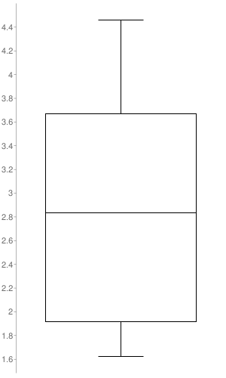

**Combination 2:**

**Population size: 6**

**Median: 2.4791666665**

**Minimum: 1.708333333**

**Maximum: 2.75**

**First quartile: 1.83333333325**

**Third quartile: 2.71874999975**

**Interquartile Range: 0.8854166665**

**Outliers: none**

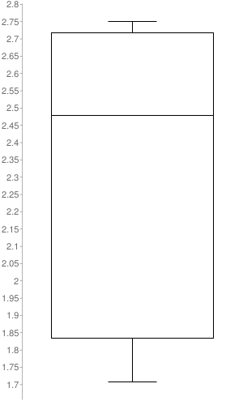

**Combination 3:**

**Population size: 10**

**Median: 2.875**

**Minimum: 1.791666667**

**Maximum: 3.875**

**First quartile: 1.885416667**

**Third quartile: 3.59374999975**

**Interquartile Range: 1.70833333275**

**Outliers: none**

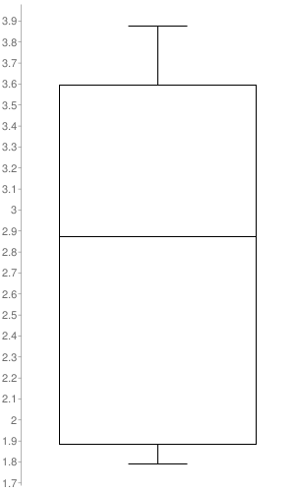

**Combination 4:**

**Sample size: 5**

**Median: 2.375**

**Minimum: 1.708333333**

**Maximum: 3.666666667**

**First quartile: 1.833333333**

**Third quartile: 3.125**

**Interquartile Range: 1.291666667**

**Outliers: none**

